1. 
2. What does it mean the text is analyzed?  
   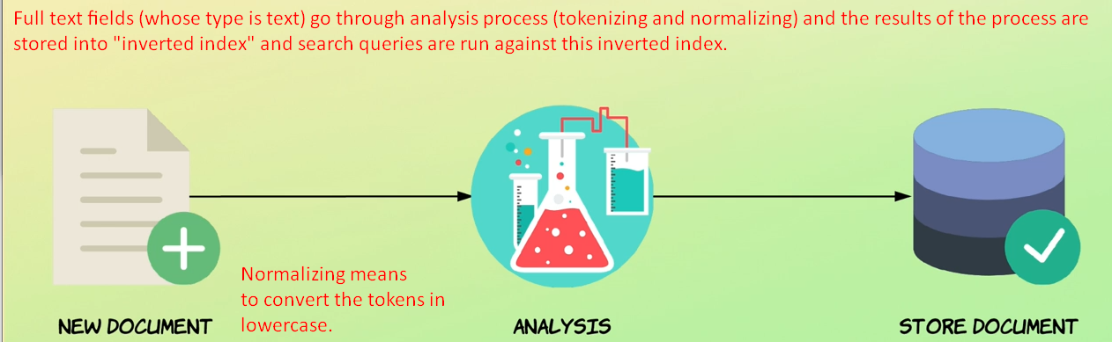
3. When indexing a document, its **full text fields** are run through an **analysis process**. By **full text fields**, I’m referred to fields of the type text and **not keyword** fields which are not analyzed.
4. We will get into detail in next lecture but basically it involves **tokenizing text in terms and normalizing** (converting the terms into lowercase).  
   More generally speaking, the **analysis process** involves **tokenizing and normalizing** (conversion to lowercase or uppercase) a block of text.  
   This is done to make the text easier to search.
5. You have full control over the analysis process because it is possible to control which analyzer is to be used.
6. The standard analyzer is sufficient in most cases but I will get back to how to change the analysis process in case you need to do that.
7. The results of the analysis are actually what are stored within the index.  
   So more specifically **analyzed terms** are stored within something called the “**inverted index**” which we will get to soon.
8. This means that whenever we perform **search queries** we’re actually searching for the results of the analysis process and not the documents as they were when we added them to the index.
9. **Recap**:
   1. When we index a doc, elasticsearch takes the **full text fields** of the document and runs them through an **analysis process** that takes full text fields and tokenize into terms and the terms are converted to lower case letters (At least that’s the default behaviour and called normalization).
   2. The results of this analysis process are added to something called the “**inverted index**” which is what we run **search queries** against.